Dubai 2019 World Para Athletics Championship
NPC Medical Team Declaration
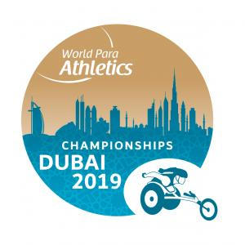

󰏚 Name of Country:
󰏚 Name of Team Leader:
󰏚 Name of Chief Physician:
󰏚 Address:
󰏚 Phone:
󰏚 E-mail:
Name | Nationality | Gender | Occupation(e.g.: Doctor, Nurse, Physical Therapist) | Passport Number | License category | License issued | License number

I hereby guarantee that the above mentioned personnel have legally obtained the necessary certified license for their medical practice under the law of ___________________(Name of Country) who possess professional medical skills and therefore hired to provide medical treatment for the team (only except masseur) at the Dubai 2019 World Para Athletics Championships. The above-mentioned personnel are all insured for malpractice and will take all responsibility for their decision and treatment.

Date:dd/mm/yyyy
(NPC President or Secretary General)
Name/Signature
----------------------------------------------------------------------------------------------------------------

※Note: The details must be filled in English on this given form. if more space is needed please feel free to use additional forms accordingly.

※Submit to:

