# THE CLASSIFICATION CASE OF AZIBO

## Welcome and instructions

### Title slides

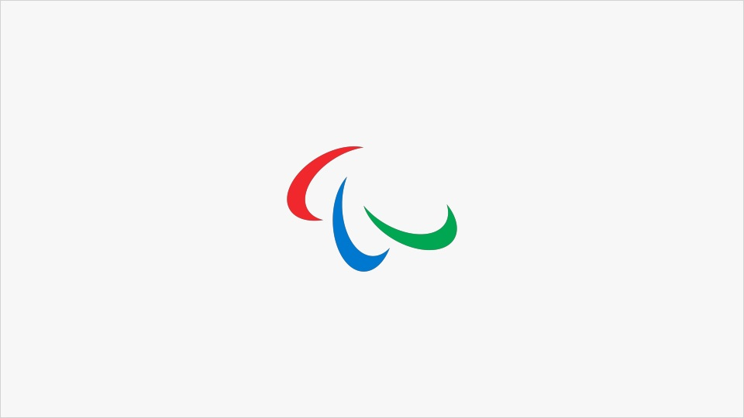

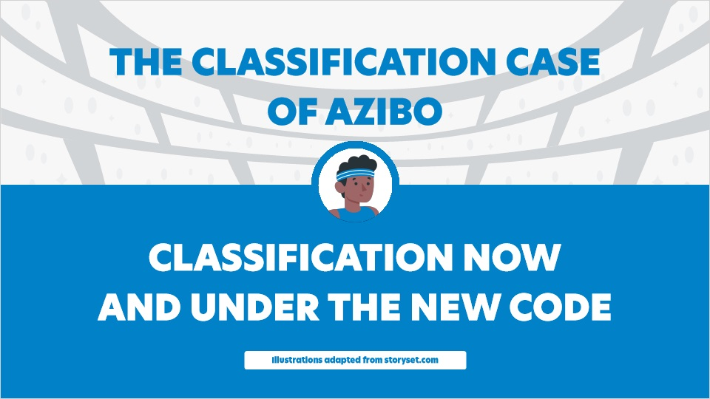

### Guidance notes

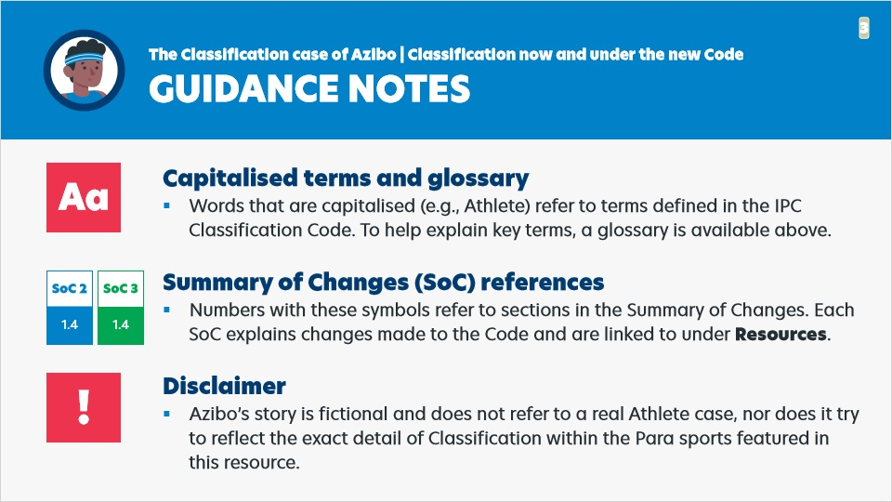

Notes:

Guidance notes

Capitalised terms and glossary:

* Words that are capitalised (e.g., Athlete) refer to terms defined in the IPC Classification Code. To help explain key terms, a glossary is available above.

Summary of Changes (SoC) references:

* Numbers with these symbols refer to sections in the Summary of Changes. Each SoC explains changes made to the Code and are linked to under Resources.

**Disclaimer:**

* Azibo’s story is fictional and does not refer to a real Athlete case, nor does it try to reflect the exact detail of Classification within the Para sports featured in this resource.

## 1. Part One | Introducing Azibo

### 1.1 Introducing Azibo 1

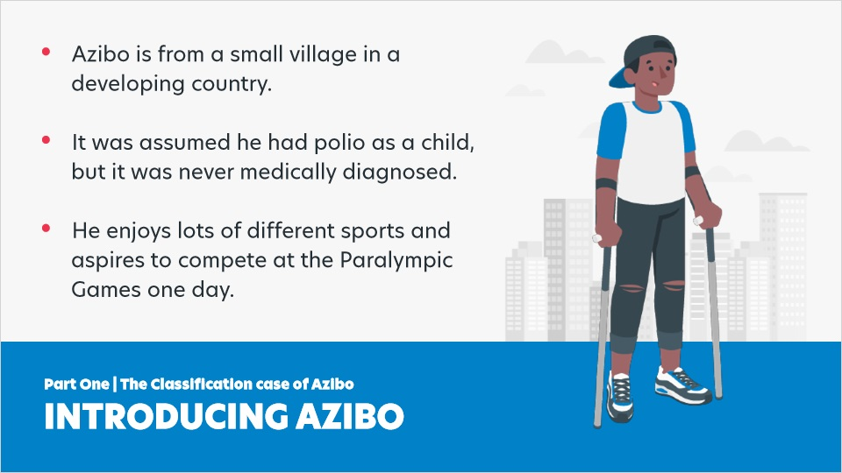

Notes:

Introducing Azibo

* Azibo is from a small village in a developing country.
* It was assumed he had polio as a child, but it was never medically diagnosed.
* He enjoys lots of different sports and aspires to compete at the Paralympic Games one day.

### 1.2 Introducing Azibo 2

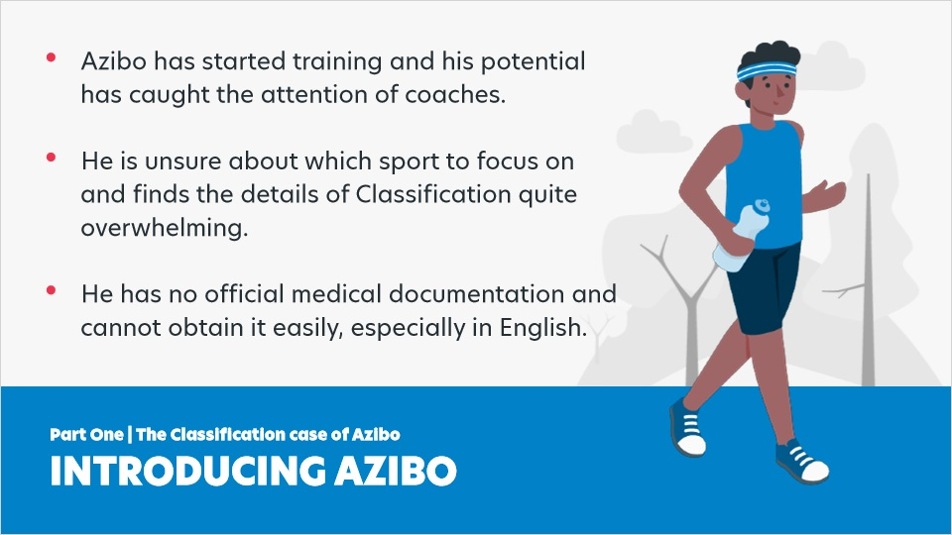

Notes:

Introducing Azibo (continued)

* Azibo has started training and his potential has caught the attention of coaches. ​
* He is unsure about which sport to focus on and finds the details of Classification quite overwhelming.​
* He has no official medical documentation and cannot obtain it easily, especially in English.​

## 2. Part Two | Azibo's Classification journey

### 2.1 Steps 1-3

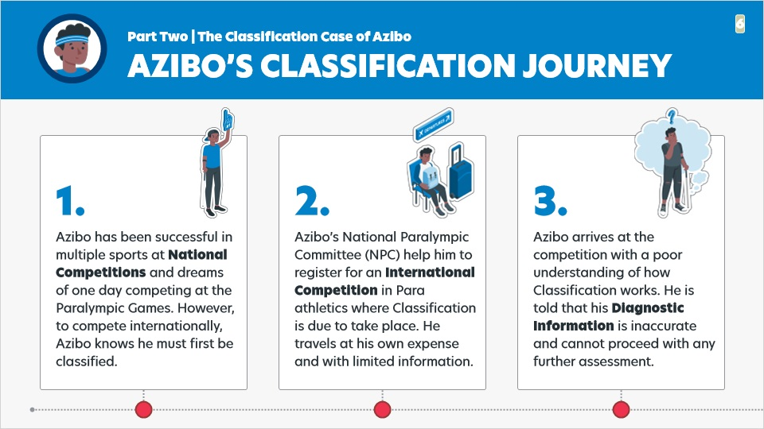

Notes:

Azibo’s Classification journey (steps 1 - 3)

1. Azibo has been successful in multiple sports at National Competitions and dreams of one day competing at the Paralympic Games. However, to compete internationally, Azibo knows he must first be classified.

2. Azibo’s National Paralympic Committee (NPC) help him to register for an International Competition in Para athletics where Classification is due to take place.​ He travels at his own expense and with limited information.

3. Azibo arrives at the competition with a poor understanding of how Classification works. He is told that his Diagnostic Information is inaccurate and cannot proceed with any further assessment.

### 2.2 Steps 4-6

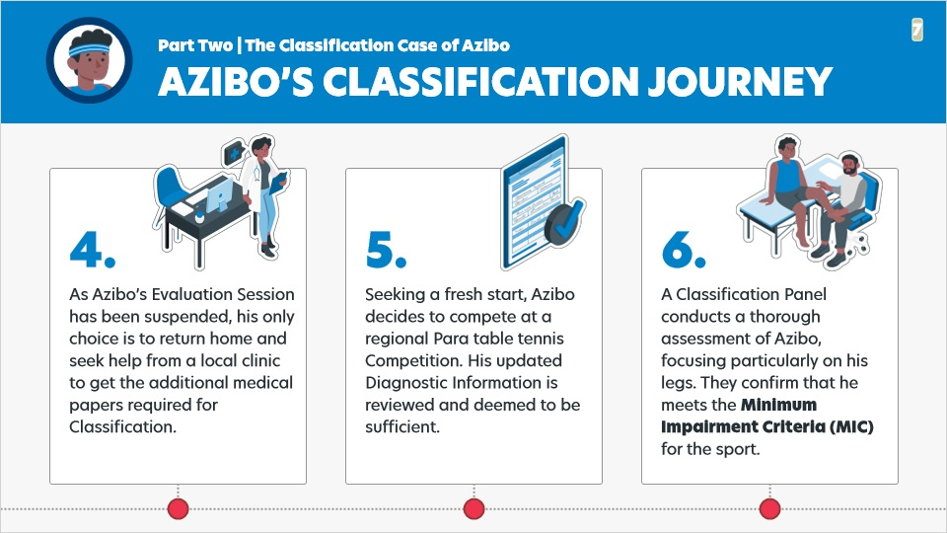

Notes:

Azibo’s Classification journey (steps 4 - 6)

4. As Azibo’s Evaluation Session has been suspended, his only choice is to return home and seek help from a local clinic to get the additional medical papers required for Classification.

5. Seeking a fresh start, Azibo decides to compete at a regional Para table tennis Competition. His updated Diagnostic Information is reviewed and deemed to be sufficient.

6. A Classification Panel conducts a thorough assessment of Azibo, focusing particularly on his legs. They confirm that he meets the Minimum Impairment Criteria (MIC) for the sport.

### 2.3 Steps 7-9

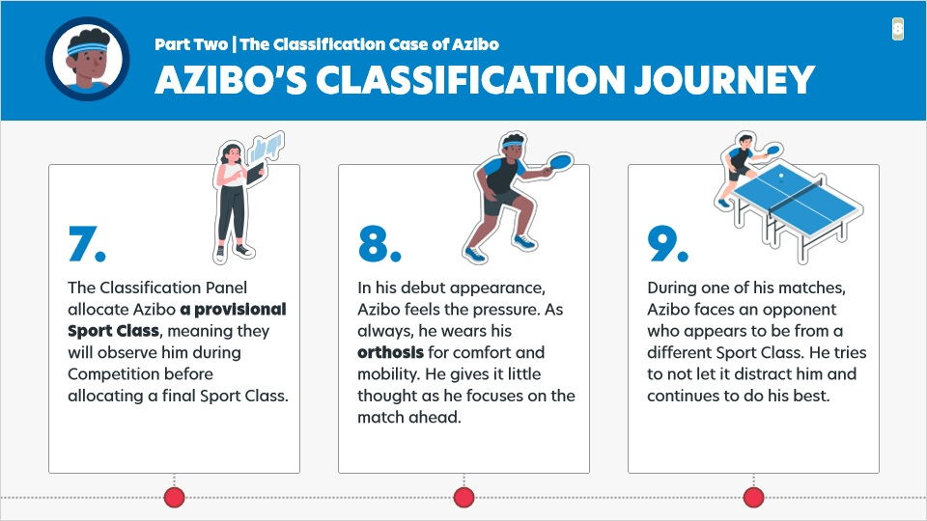

Notes:

Azibo’s Classification journey (steps 7 - 9)

7. The Classification Panel allocate Azibo a provisional Sport Class, meaning they will observe him during Competition before allocating a final Sport Class.

8. In his debut appearance, Azibo feels the pressure. As always, he wears his orthosis for comfort and mobility. He gives it little thought as he focuses on the match ahead.

9. During one of his matches, Azibo faces an opponent who appears to be from a different Sport Class. He tries to not let it distract him and continues to do his best.

### 2.4 Steps 10-12

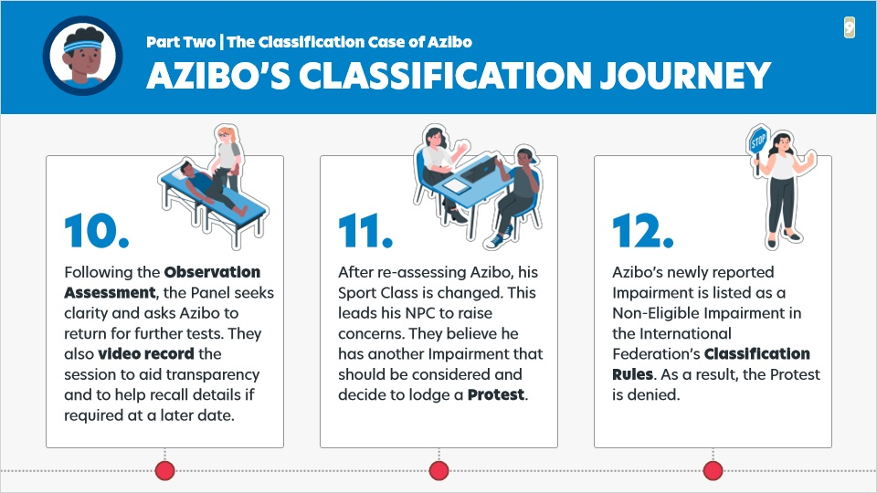

Notes:

Azibo’s Classification journey (steps 10 - 12)

10. Following the Observation Assessment, the Panel seeks clarity and asks Azibo to return for further tests. They also video record the session to aid transparency and to help recall details if required at a later date.

11. After re-assessing Azibo, his Sport Class is changed. This leads his NPC to raise concerns. They believe he has another Impairment that should be considered and decide to lodge a Protest.

12. Azibo’s newly reported Impairment is listed as a Non-Eligible Impairment in the International Federation’s Classification Rules. As a result, the Protest is denied.

### 2.5 Steps 13-14

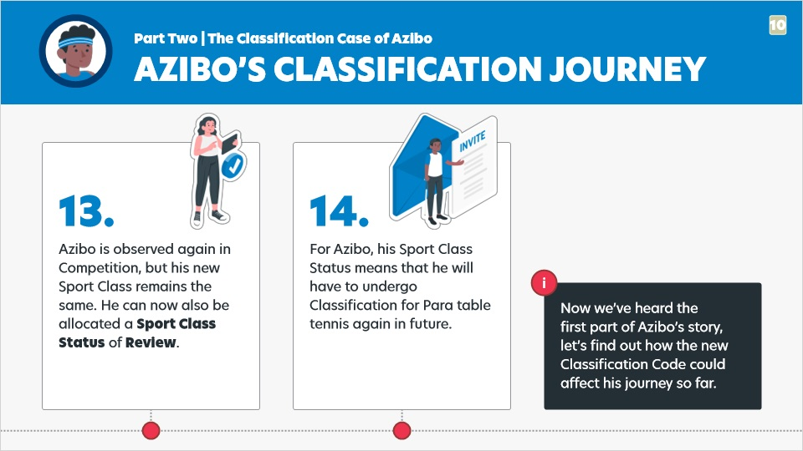

Notes:

Azibo’s Classification journey (steps 13 - 14)

13. Azibo is observed again in Competition, but his new Sport Class remains the same. He can now also be allocated a Sport Class Status of Review.

14. For Azibo, his Sport Class Status means that he will have to undergo Classification for Para table tennis again in future.

Now we’ve heard the first part of Azibo’s story, let’s find out how the new Classification Code could affect his journey so far.

## 3. Part Three | How could the new Code affect Azibo? (1)

### 3.1 How could the new Code affect Azibo?

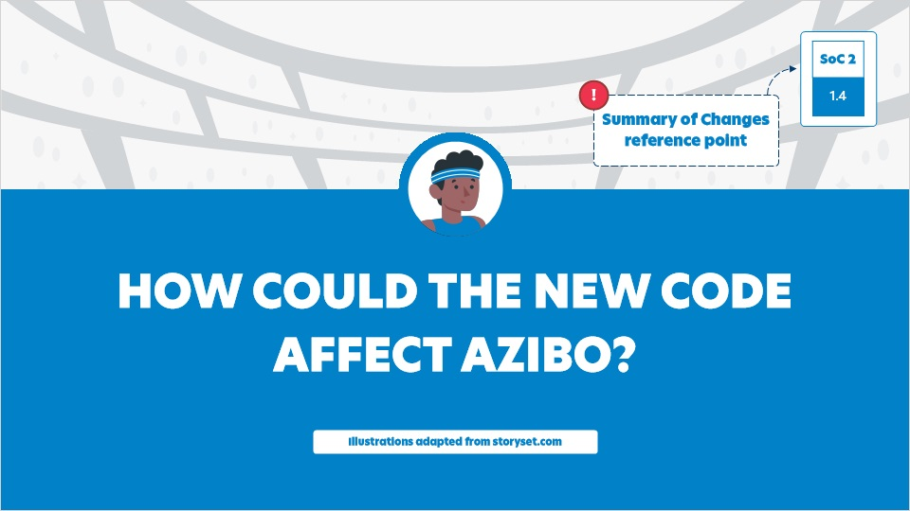

Notes:

How could the new Code affect Azibo?

### 3.2 Step 3 (1)

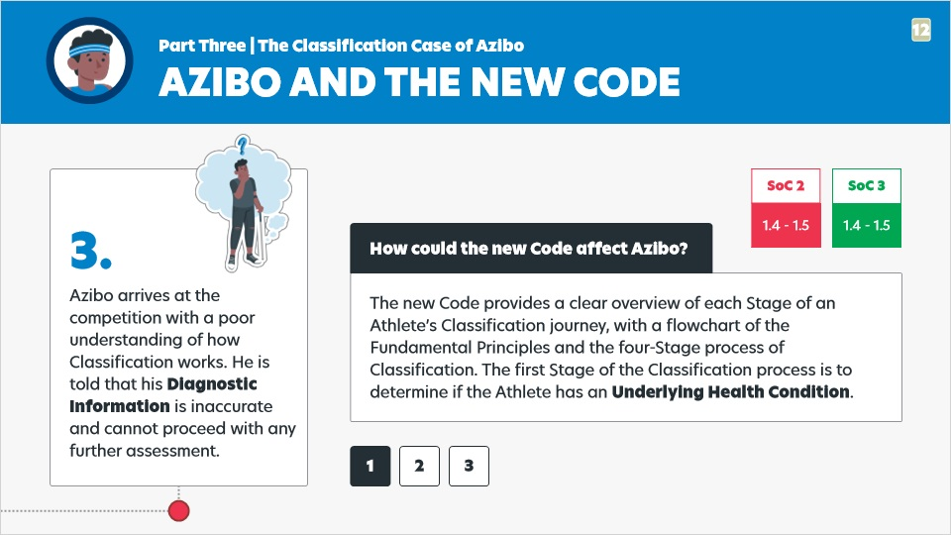

Notes:

How could the new Code affect Azibo? Step 3, part 1.

Azibo arrives at the competition with a poor understanding of how Classification works. He is told that his Diagnostic Information is inaccurate and cannot proceed with any further assessment.

The new Code provides a clear overview of each Stage of an Athlete’s Classification journey, with a flowchart of the Fundamental Principles and the four-Stage process of Classification. The first Stage of the Classification process is to determine if the Athlete has an Underlying Health Condition.​

### 3.3 Step 3 (2)

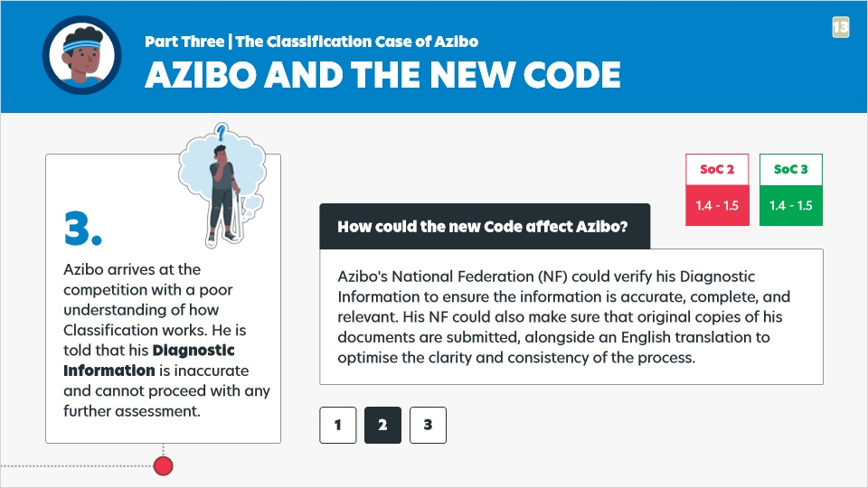

Notes:

How could the new Code affect Azibo? Step 3, part 2.

Azibo arrives at the competition with a poor understanding of how Classification works. He is told that his Diagnostic Information is inaccurate and cannot proceed with any further assessment.

Azibo's National Federation (NF) could verify his Diagnostic Information to ensure the information is accurate, complete, and relevant. His NF could also make sure that original copies of his documents are submitted, alongside an English translation to optimise the clarity and consistency of the process.

### 3.4 Step 3 (3)

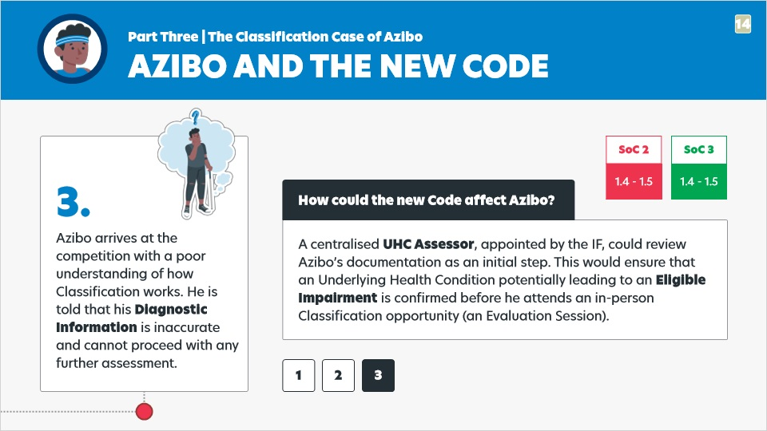

Notes:

How could the new Code affect Azibo? Step 3, part 3.

Azibo arrives at the competition with a poor understanding of how Classification works. He is told that his Diagnostic Information is inaccurate and cannot proceed with any further assessment.

A centralised UHC Assessor, appointed by the IF, could review Azibo’s documentation as an initial step. This would ensure that an Underlying Health Condition potentially leading to an Eligible Impairment is confirmed before he attends an in-person Classification opportunity (an Evaluation Session).​

### 3.5 Step 4 (1)

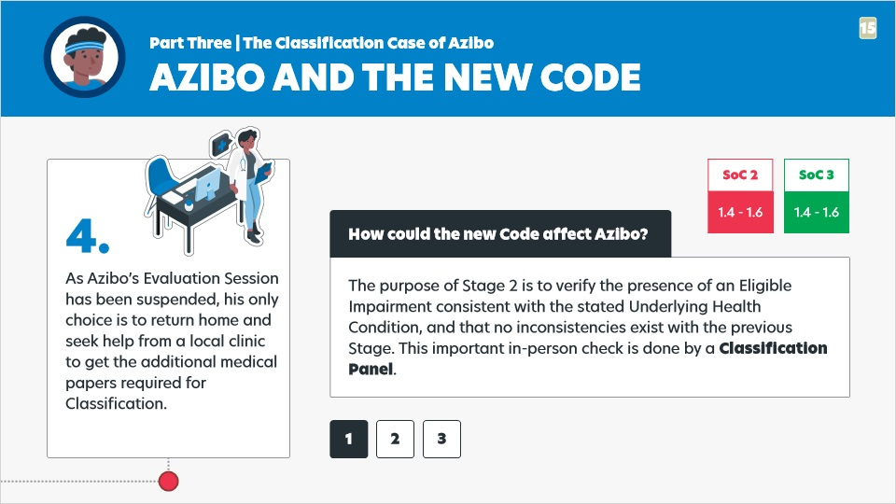

Notes:

How could the new Code affect Azibo? Step 4, part 1.

As Azibo’s Evaluation Session has been suspended, his only choice is to return home and seek help from a local clinic to get the additional medical papers required for Classification.

The purpose of Stage 2 is to verify the presence of an Eligible Impairment consistent with the stated Underlying Health Condition, and that no inconsistencies exist with the previous Stage. This important in-person check is done by a Classification Panel.

### 3.6 Step 4 (2)

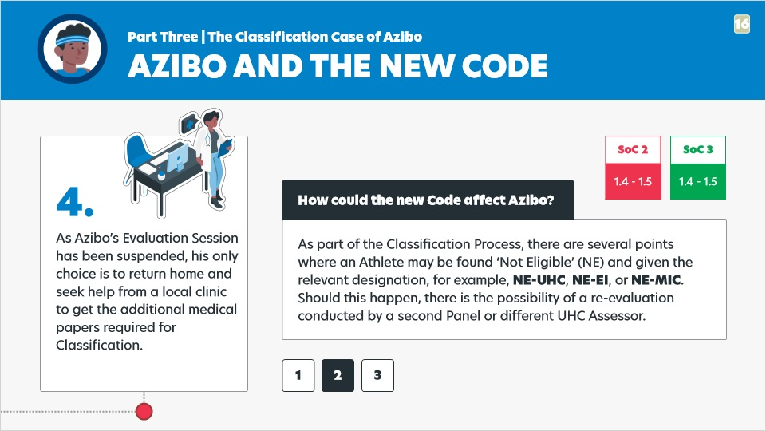

Notes:

How could the new Code affect Azibo? Step 4, part 2.

As Azibo’s Evaluation Session has been suspended, his only choice is to return home and seek help from a local clinic to get the additional medical papers required for Classification.

As part of the Classification Process, there are several points where an Athlete may be found ‘Not Eligible’ (NE) and given the relevant designation, for example, NE-UHC, NE-EI, or NE-MIC. Should this happen, there is the possibility of a re-evaluation conducted by a second Panel or different UHC Assessor.

### 3.7 Step 4 (3)

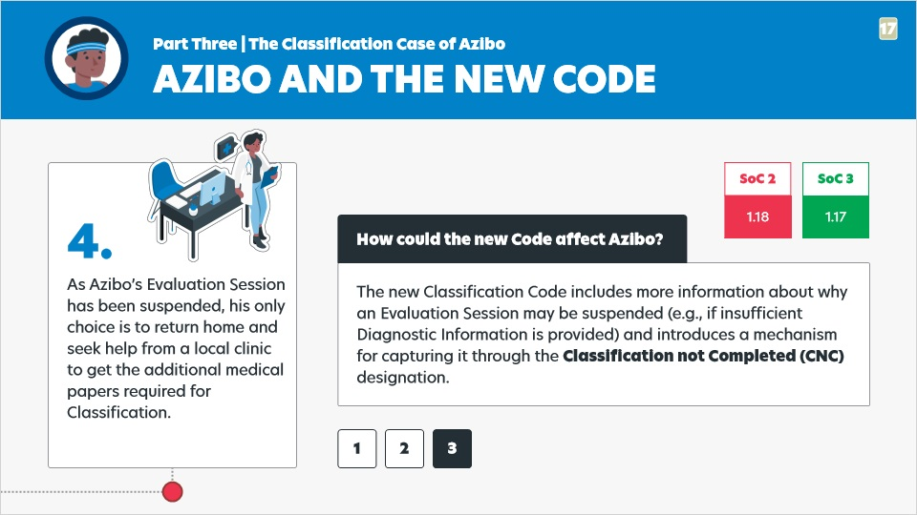

Notes:

How could the new Code affect Azibo? Step 4, part 3.

As Azibo’s Evaluation Session has been suspended, his only choice is to return home and seek help from a local clinic to get the additional medical papers required for Classification.

The new Classification Code includes more information about why an Evaluation Session may be suspended (e.g., if insufficient Diagnostic Information is provided) and introduces a mechanism for capturing it through the Classification not Completed (CNC) designation.​

### 3.8 Step 6

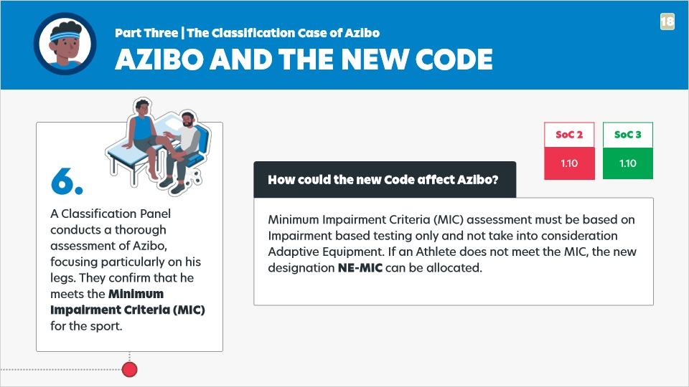

Notes:

How could the new Code affect Azibo? Step 6.

A Classification Panel conducts a thorough assessment of Azibo, focusing particularly on his legs. They confirm that he meets the Minimum Impairment Criteria (MIC) for the sport.

Minimum Impairment Criteria (MIC) assessment must be based on Impairment based testing only and not take into consideration Adaptive Equipment. If an Athlete does not meet the MIC, the new designation NE-MIC can be allocated.

### 3.9 Step 7 (1)

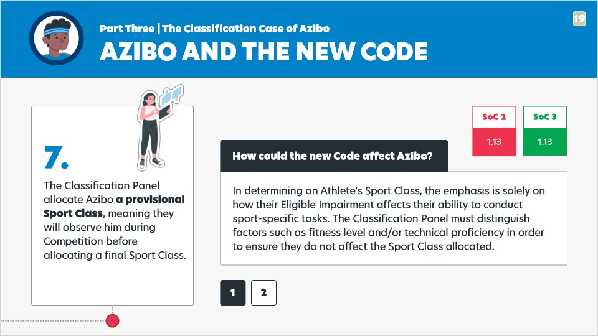

Notes:

How could the new Code affect Azibo? Step 7, part 1.

The Classification Panel allocate Azibo a provisional Sport Class, meaning they will observe him during Competition before allocating a final Sport Class.

In determining an Athlete's Sport Class, the emphasis is solely on how their Eligible Impairment affects their ability to conduct sport-specific tasks. The Classification Panel must distinguish factors such as fitness level and/or technical proficiency in order to ensure they do not affect the Sport Class allocated.

### 3.10 Step 7 (2)

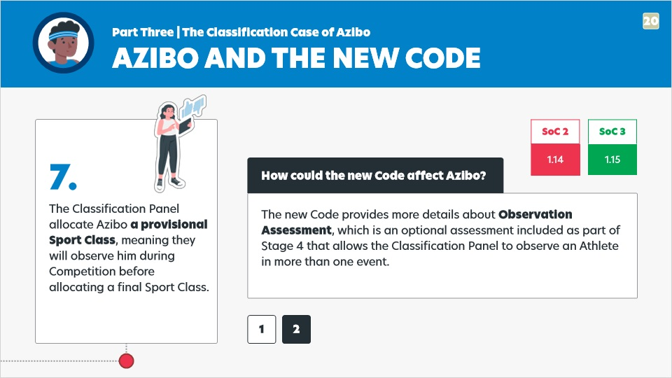

Notes:

How could the new Code affect Azibo? Step 7, part 2.

The Classification Panel allocate Azibo a provisional Sport Class, meaning they will observe him during Competition before allocating a final Sport Class.

The new Code provides more details about Observation Assessment, which is an optional assessment included as part of Stage 4 that allows the Classification Panel to observe an Athlete in more than one event.

### 3.11 Step 8

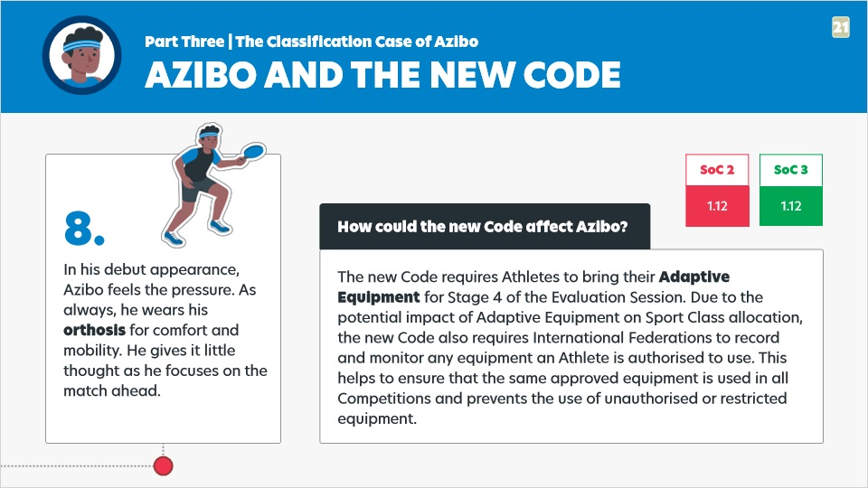

Notes:

How could the new Code affect Azibo? Step 8.

In his debut appearance, Azibo feels the pressure. As always, he wears his orthosis for comfort and mobility. He gives it little thought as he focuses on the match ahead.

The new Code requires Athletes to bring their Adaptive Equipment for Stage 4 of the Evaluation Session. Due to the potential impact of Adaptive Equipment on Sport Class allocation, the new Code also requires International Federations to record and monitor any equipment an Athlete is authorised to use. This helps to ensure that the same approved equipment is used in all Competitions and prevents the use of unauthorised or restricted equipment.

### 3.12 Step 9

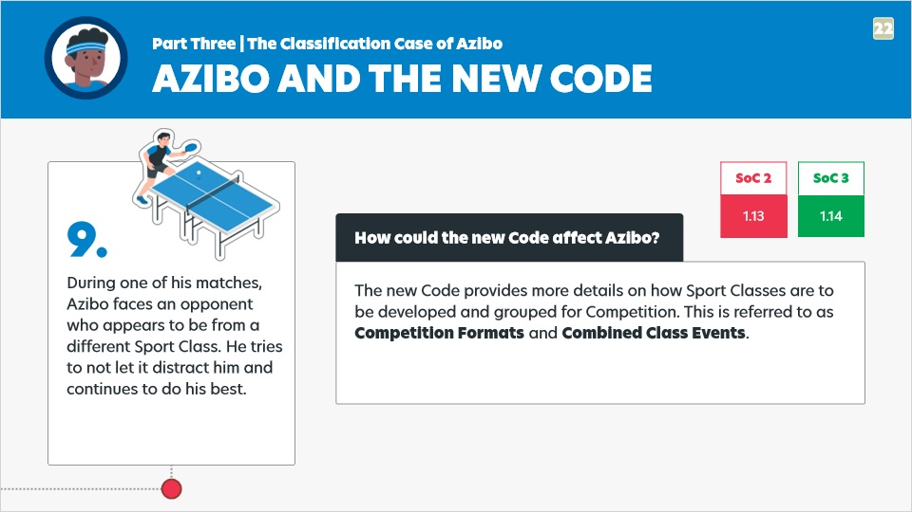

Notes:

How could the new Code affect Azibo? Step 9.

During one of his matches, Azibo faces an opponent who appears to be from a different Sport Class. He tries to not let it distract him and continues to do his best.

The new Code provides more details on how Sport Classes are to be developed and grouped for Competition. This is referred to as Competition Formats and Combined Class Events.​

### 3.13 Step 10

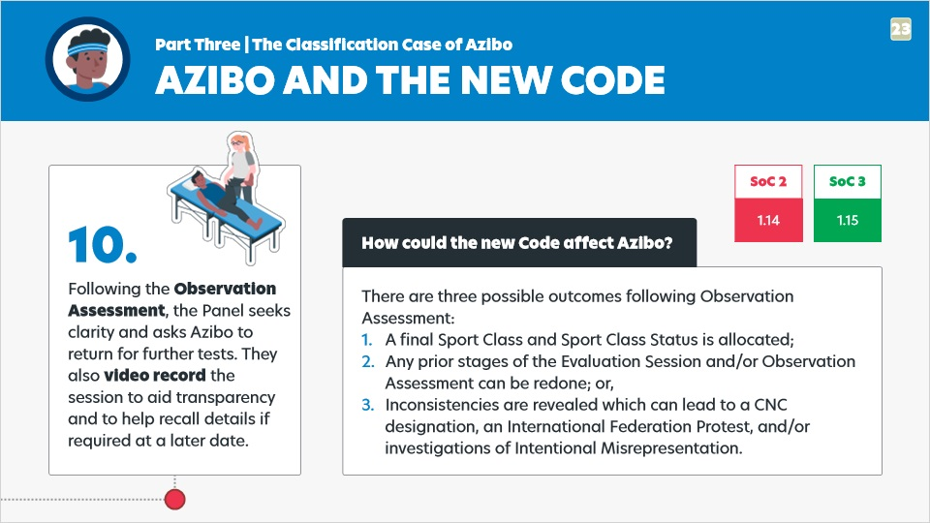

Notes:

How could the new Code affect Azibo? Step 10.

Following the Observation Assessment, the Panel seeks clarity and asks Azibo to return for further tests. They also video record the session to aid transparency and to help recall details if required at a later date.

There are three possible outcomes following Observation Assessment:​

1. A final Sport Class and Sport Class Status is allocated;​
2. Any prior stages of the Evaluation Session and/or Observation Assessment can be redone; or,
3. Inconsistencies are revealed which can lead to a CNC designation, an International Federation Protest, and/or investigations of Intentional Misrepresentation.

### 3.14 Step 12 (1)

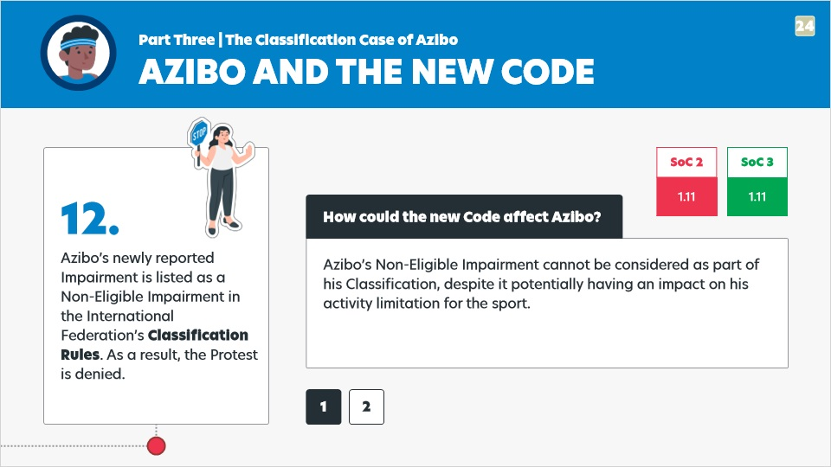

Notes:

How could the new Code affect Azibo? Step 12, part 1.

Azibo’s newly reported Impairment is listed as a Non-Eligible Impairment in the International Federation’s Classification Rules. As a result, the Protest is denied.

Azibo’s Non-Eligible Impairment cannot be considered as part of his Classification, despite it potentially having an impact on his activity limitation for the sport.​

### 3.15 Step 12 (2)

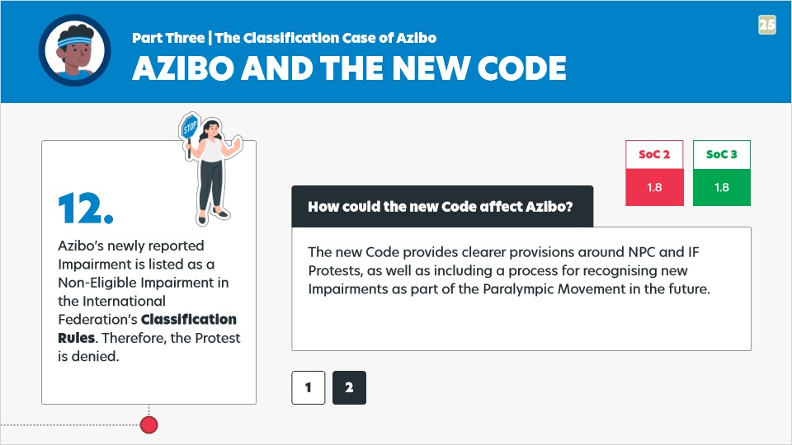

Notes:

How could the new Code affect Azibo? Step 12, part 2.

Azibo’s newly reported Impairment is listed as a Non-Eligible Impairment in the International Federation’s Classification Rules. Therefore, the Protest is denied.

The new Code provides clearer provisions around NPC and IF Protests, as well as including a process for recognising new Impairments as part of the Paralympic Movement in the future.​

### 3.16 Step 13

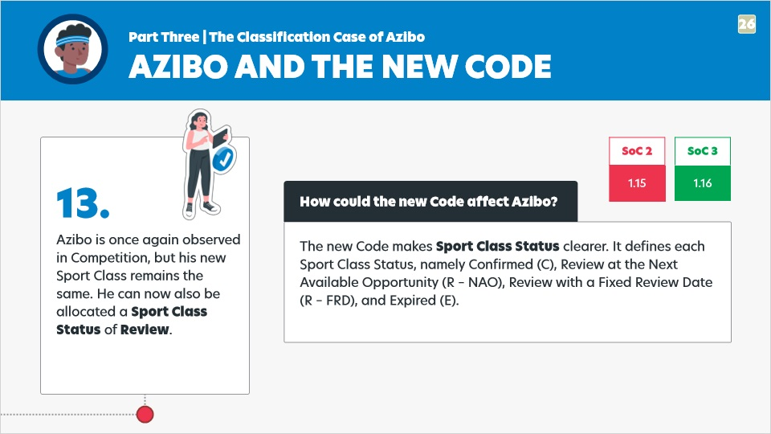

Notes:

How could the new Code affect Azibo? Step 13.

Azibo is once again observed in Competition, but his new Sport Class remains the same. He can now also be allocated a Sport Class Status of Review.

The new Code makes Sport Class Status clearer. It defines each Sport Class Status, namely Confirmed (C), Review at the Next Available Opportunity (R – NAO), Review with a Fixed Review Date (R – FRD), and Expired (E).

### 3.17 Step 14

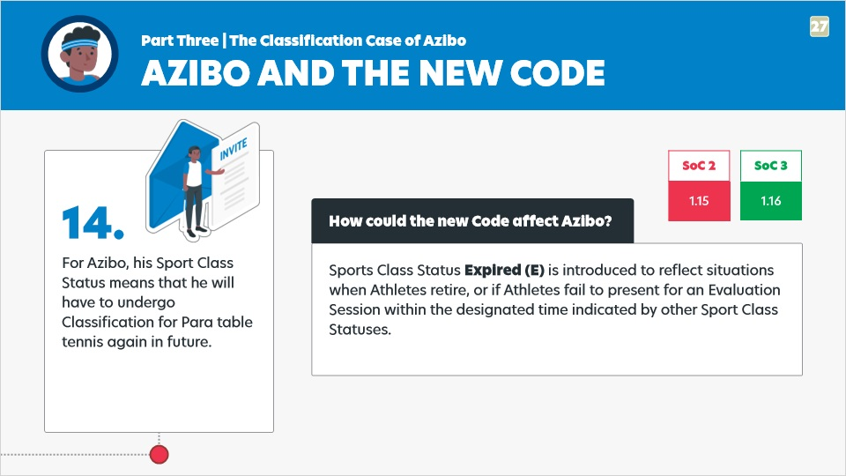

Notes:

How could the new Code affect Azibo? Step 14.

For Azibo, his Sport Class Status means that he will have to undergo Classification for Para table tennis again in future.

Sports Class Status Expired (E) is introduced to reflect situations when Athletes retire, or if Athletes fail to present for an Evaluation Session within the designated time indicated by other Sport Class Statuses.

## 4. Part Four | Azibo's journey continues...

### 4.1 Steps 15-17

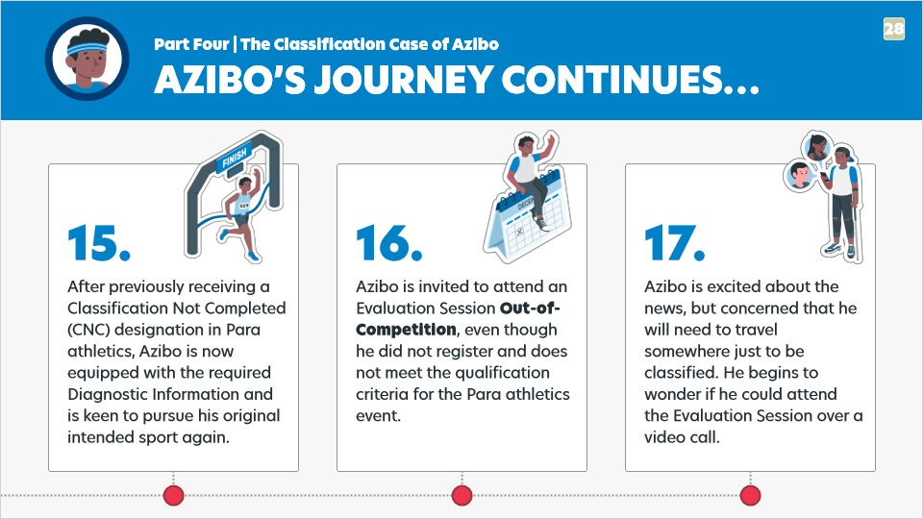

Notes:

Azibo’s Classification journey continues… (Steps 15 - 17)

15. After previously receiving a Classification Not Completed (CNC) designation in Para athletics, Azibo is now equipped with the required Diagnostic Information and is keen to pursue his original intended sport again.

16. Azibo is invited to attend an Evaluation Session Out-of-Competition, even though he did not register and does not meet the qualification criteria for the Para athletics event.

17. Azibo is excited about the news, but concerned that he will need to travel somewhere just to be classified. He begins to wonder if he could attend the Evaluation Session over a video call.​

## 5. Part Five | How could the new Code affect Azibo? (2)

### 5.1 Step 16

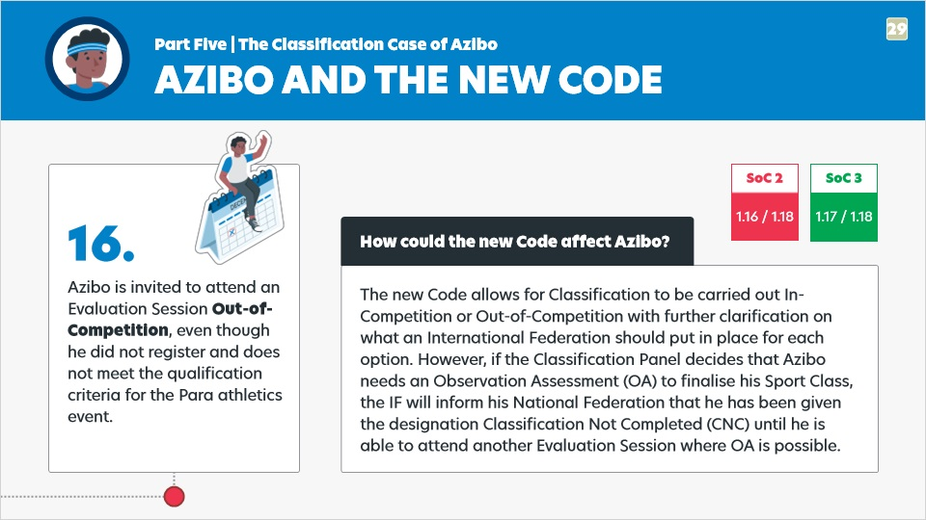

Notes:

How could the new Code affect Azibo? Step 16.

Azibo is invited to attend an Evaluation Session Out-of-Competition, even though he did not register and does not meet the qualification criteria for the Para athletics event.

The new Code allows for Classification to be carried out In-Competition or Out-of-Competition with further clarification on what an International Federation should put in place for each option. However, if the Classification Panel decides that Azibo needs an Observation Assessment (OA) to finalise his Sport Class, the IF will inform his National Federation that he has been given the designation Classification Not Completed (CNC) until he is able to attend another Evaluation Session where OA is possible.

### 5.2 Step 17 (1)

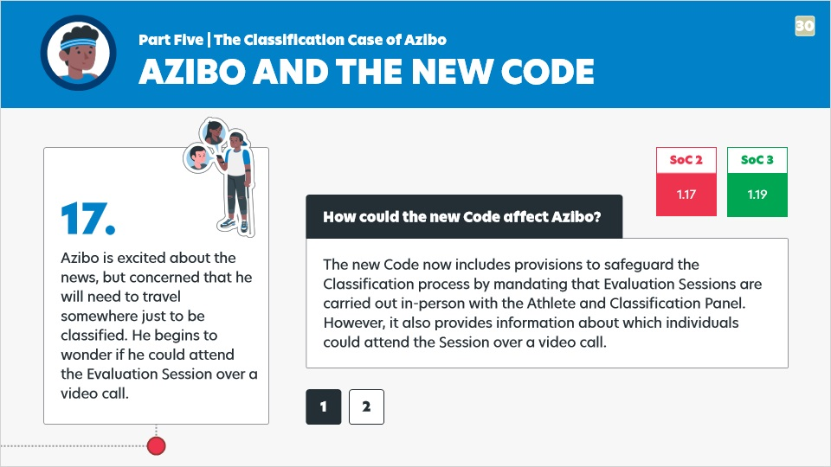

Notes:

How could the new Code affect Azibo? Step 17, part 1.

Azibo is excited about the news, but concerned that he will need to travel somewhere just to be classified. He begins to wonder if he could attend the Evaluation Session over a video call.​

The new Code now includes provisions to safeguard the Classification process by mandating that Evaluation Sessions are carried out in-person with the Athlete and Classification Panel. However, it also provides information about which individuals could attend the Session over a video call.

### 5.3 Step 17 (2)

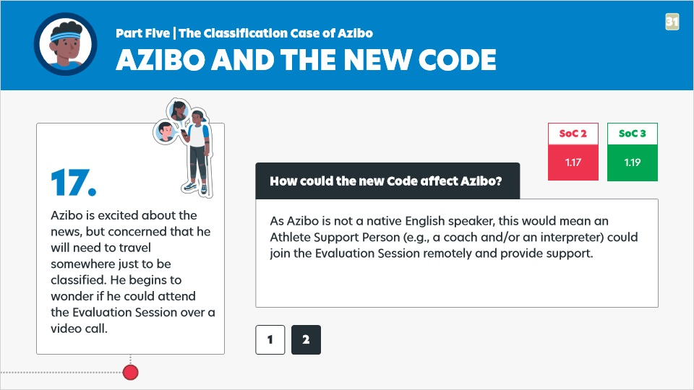

Notes:

How could the new Code affect Azibo? Step 17, part 2.

Azibo is excited about the news, but concerned that he will need to travel somewhere just to be classified. He begins to wonder if he could attend the Evaluation Session over a video call.​

As Azibo is not a native English speaker, this would mean an Athlete Support Person (e.g., a coach and/or an interpreter) could join the Evaluation Session remotely and provide support.

*Illustrations adapted from* [*storyset.com*](https://storyset.com/)