
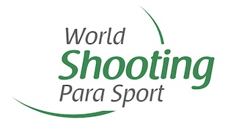
LOC or competition
sponsor
LOC or competition
sponsor
LOC or competition
sponsor
LOC or competition
sponsor
LOC or competition
sponsor
LOC or
competition
logo
Athlete Bib Template

SDMS #
Family Name, Given Name
Class-Subclass (SH2Aa) Loader (L) VfH (34)
Country Code

Loader Bib Template
LOC or
competition
logo

SDMS #
LOADER
Family Name, Given Name
Country Code
LOC or competition
sponsor
LOC or competition
sponsor
LOC or competition
sponsor
LOC or competition
sponsor
LOC or competition
sponsor

